100 E. Main
Goessel, KS, 67053
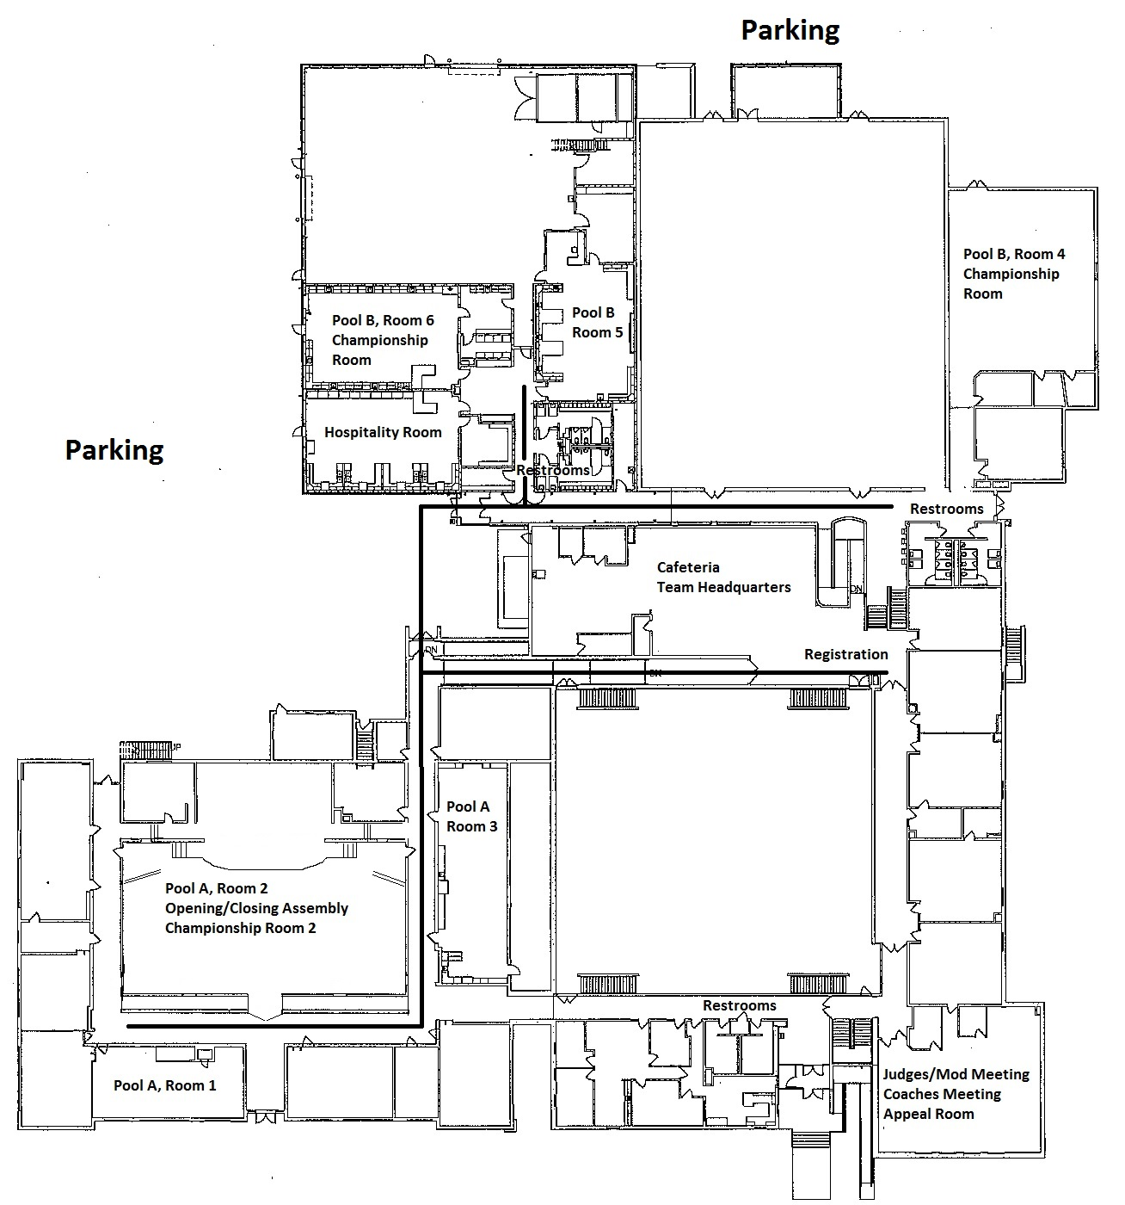
620-367-2242
Entrance
Main Street
Church Street
Goessel High School
100 E. Main
Goessel, KS 67053
½ mile West off HWY 15,
North side of Road

Directions to Goessel:

From Salina: Take I-135 South to McPherson, go East on HWY 56 to HWY 15, turn South 8 miles on HWY 15
(Approximate time from Salina: 1 hour)

From Wichita: Take I-135 North to North Newton exit (Abilene HWY 15 exit), turn North on HWY 15 and go 11 miles
(Approximate time from Wichita: 45-50 minutes)

From Emporia: Take HWY 50 southwest out of Emporia to HWY 56 (via HWY 150 and Marion), Go West on HWY 56 to
HWY 15, turn south on HWY 15 8 miles (Approximate time from Emporia: 1 hour 15 minutes)

From Abilene: Take HWY 15 south to HWY 15/HWY 56 Merge; turn WEST on HWY 15/56 until
Junction to HWY 15 (approx 5 miles); turn south on HWY 15 for 8 miles to Goessel
(Approximate time: 1 hour)

